CSIT314 Software Development Methodologies - Group Project

Sprint 1 - US11: Suspend user account
Interior Design Platform - User Admin
All diagrams were drawn in draw.io. Open "US11 Suspend user account.drawio" in this folder to edit them - each diagram is its own page in that file. The exported images are in the "diagrams" folder.

Assumptions
- The system is the Interior Design Platform from the project specification. Sprint 1 covers the User Admin's stories: log in and log out (US1, US2), managing user profiles (US3 - US7) and managing user accounts (US8 - US12).
- A user account is one person's login. It has a username, password, full name, email, phone, the user profile (group) it belongs to, a status (Active or Suspended) and the date it was created. Every account belongs to exactly one user profile and gets that profile's permissions.
- We follow B-C-E: the actor only talks to the boundary (page), the boundary only talks to the controller, and the controller works with the entity classes. There is one controller per use case.
- Who checks what: the boundary (page) checks the input - the User Admin can't suspend their own account (userId != session userId). The controller just calls the entity and returns the result. The entity checks the database state (only an Active account is changed), then saves.
- Being logged in as a User Admin (UC1) is a precondition, not a step: loginRequired in app.py only sends someone with no session to /login, and this use case doesn't check the role again.
- The account shown in the confirmation box belongs to US9, so the page borrows US9's ViewUserAccountController.viewUserAccount() for it, instead of adding a load method to the US11 controller.
- Suspending only changes the account's status to Suspended. Nothing is deleted.
- Log in (US1) only lets an Active account in (UserAccount.verifyCredentials), so this is what stops the user from logging in. Other accounts in the same user profile are not affected.
- The User Admin can't suspend their own account, otherwise they could lock themselves out. The page checks this itself: it compares the userId with the logged-in admin's own userId in the session (session userId) and only calls the controller when they are different.
- An account that is already suspended can't be suspended again. Making an account active again is not part of this sprint.

1. User story
Story ID | US11
User story | As a user admin, I want to suspend a user account so that the user cannot log in.
Actor | User Admin
Priority | Medium
Story points (estimate) | 3
Acceptance criteria | 1. Given I am viewing an active account that isn't my own, there is a "Suspend" button.  2. Given I click "Suspend", then a confirmation box tells me which account will be suspended and that the user won't be able to log in.  3. Given I confirm, then the status changes to "Suspended" and I see "User account suspended successfully".  4. Given an account is suspended, when that user tries to log in, then they can't (they get the login error).  5. Other users can still log in, and no account is deleted.  6. Given I click "Cancel" in the confirmation box, then nothing changes.  7. I can't suspend an account that is already suspended, or my own account.
Tasks | T11.1 Write the use case description and draw the use case diagram  T11.2 Draw the B-C-E class diagram and the sequence diagram  T11.3 Draw the wireframes for the Suspend button, the confirmation box, the suspended account and the blocked login  T11.4 Write the unit tests first (TDD) for UserAccount.suspendUserAccount() and SuspendUserAccountController  T11.5 Code UserAccount.suspendUserAccount() (only an Active account is changed)  T11.6 Code SuspendUserAccountController.suspendUserAccount(userId) (just calls the entity)  T11.7 Code SuspendUserAccountPage: Suspend button, confirmation box (account from US9's controller), the own-account check and the messages  T11.8 Check that Log in (US1) refuses suspended accounts  T11.9 Run the test cases, fix bugs and push to the repo so the CI pipeline runs the unit tests

2. Use case diagram
The user story becomes one use case, UC11 Suspend user account. The User Admin is the only actor.
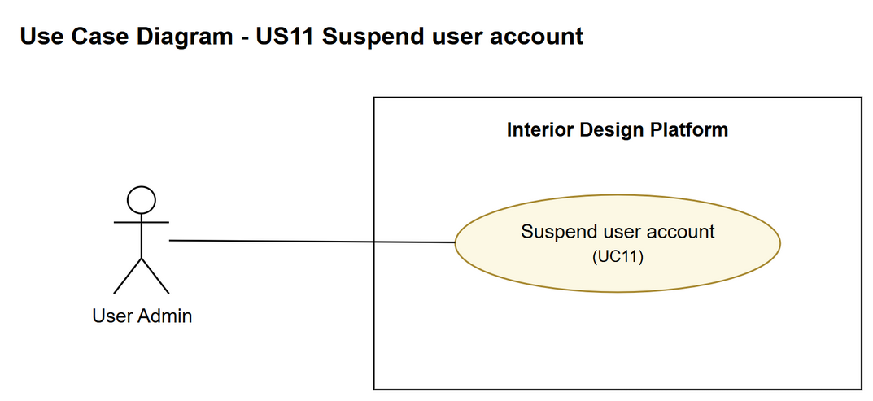
Figure 1: Use case diagram for US11 Suspend user account

3. Use case description
Use case | UC11 Suspend user account
Actor | User Admin
Brief description | The User Admin suspends one user account so that the user can't log in. Nothing is deleted.
User story | US11: As a user admin, I want to suspend a user account so that the user cannot log in.
Preconditions | The User Admin is logged in (UC1).  The User Admin is viewing a user account (UC9).
Trigger | The User Admin clicks "Suspend" on the account's details page.
Basic flow | 1. The User Admin clicks "Suspend".  2. The system gets the account (the same way as UC9 View user account).  3. The system asks the User Admin to confirm, saying which account will be suspended and that the user won't be able to log in.  4. The User Admin clicks "Suspend" to confirm.  5. The system checks that it is not the User Admin's own account.  6. The system changes the account's status to "Suspended" (only if it is still Active).  7. The system shows "User account suspended successfully" and the account with status Suspended.
Alternative flows | 2a. The account doesn't exist: the system shows "This user account cannot be suspended" and nothing changes.  4a. The User Admin clicks "Cancel": the confirmation box closes and nothing changes.  5a. It is the User Admin's own account: the system shows "This user account cannot be suspended" and nothing changes.  6a. The account is not Active any more (already suspended): the system shows "This user account cannot be suspended" and nothing changes.  (Normally the Suspend button isn't even shown in 5a and 6a.)
Postconditions | The user account's status is "Suspended".  The user can no longer log in (UC1).  No user account is deleted.

4. Wireframes
The wireframes were drawn in draw.io. They are low-fidelity: they show the layout and the flow, not the final colours. The orange numbers match the notes under each screen.

4a - Suspend button
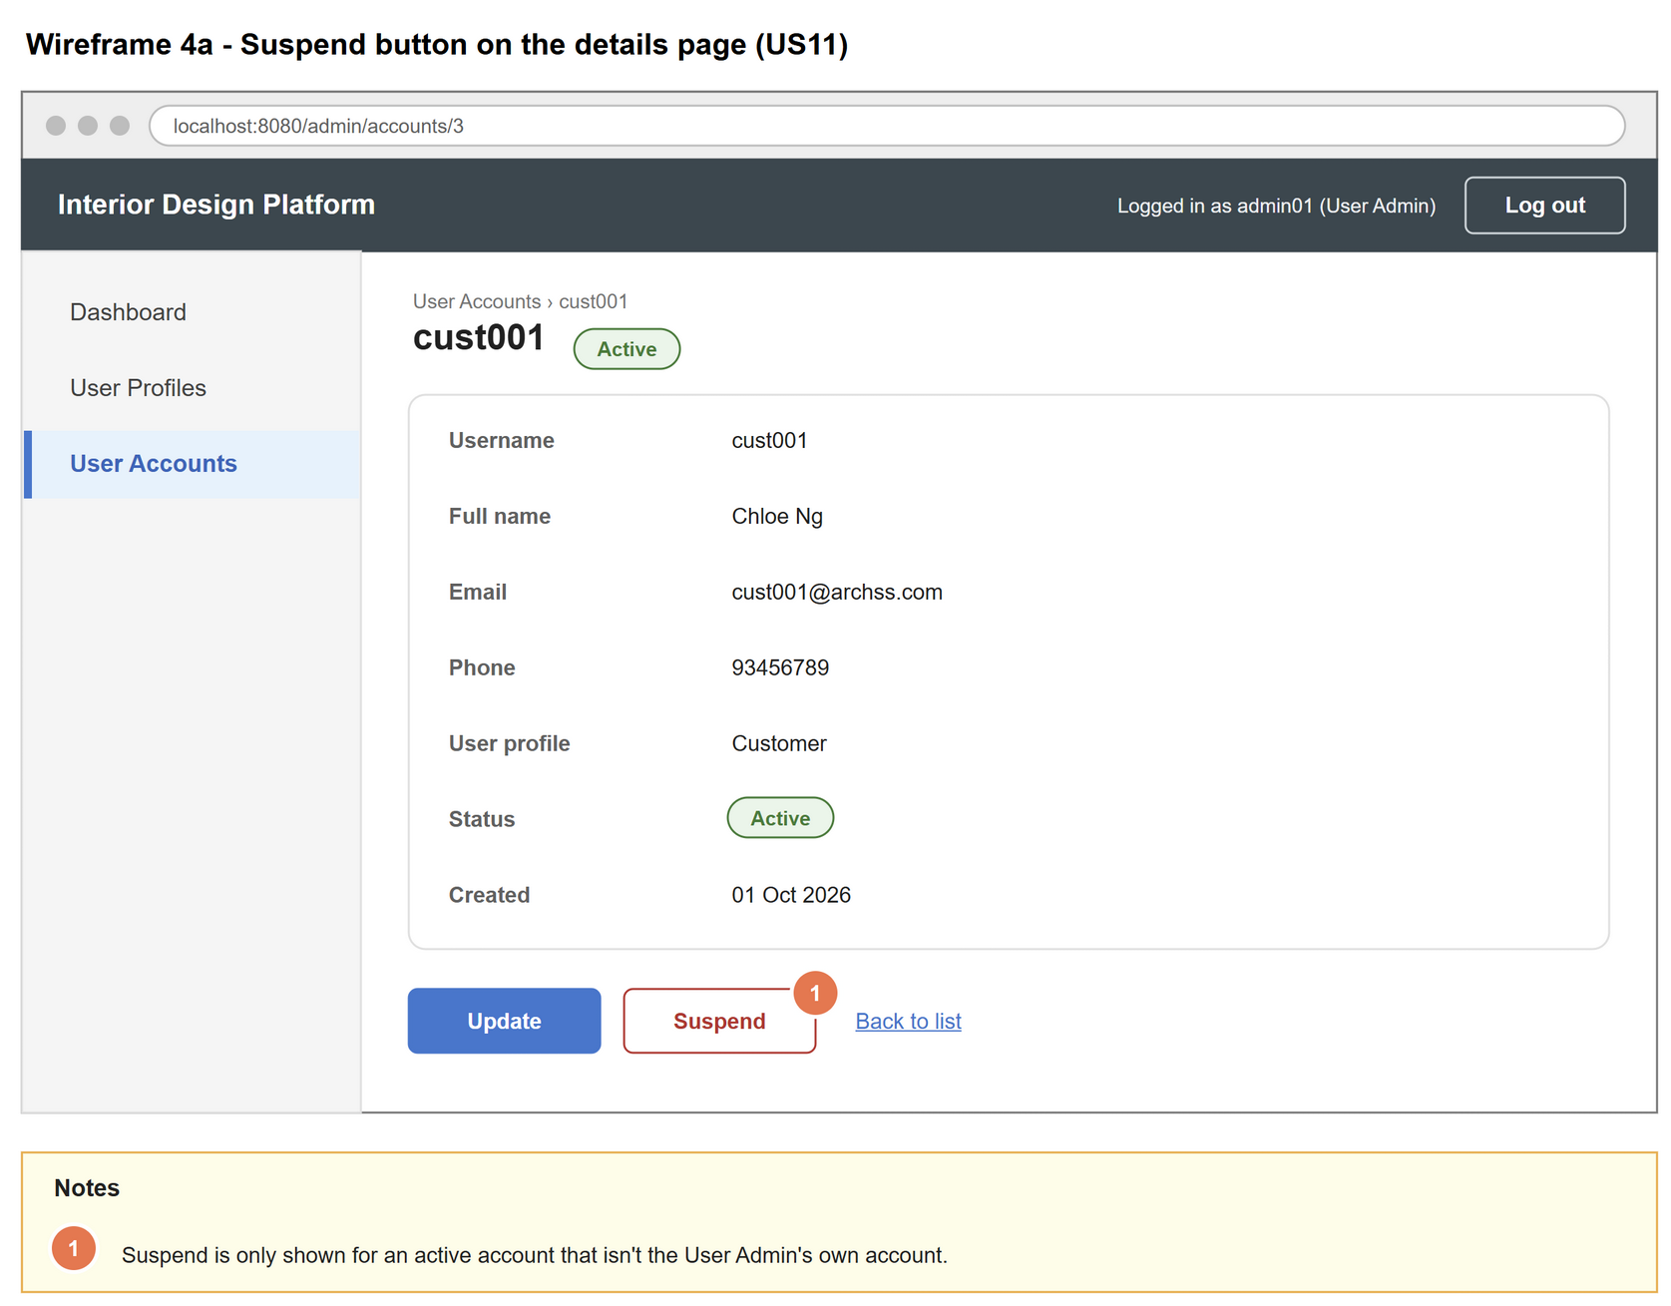
Figure 2: Wireframe 4a - Suspend button (US11)

4b - Confirm suspend
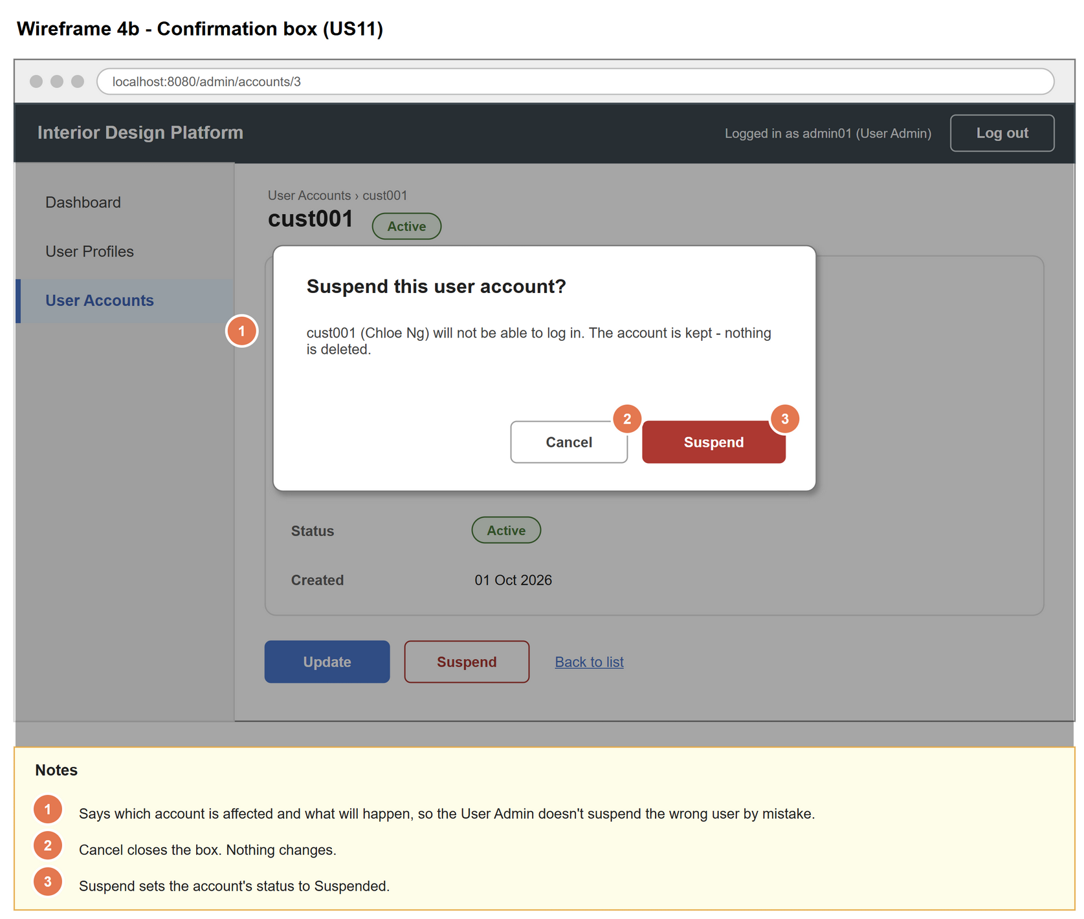
Figure 3: Wireframe 4b - Confirm suspend (US11)

4c - Account suspended
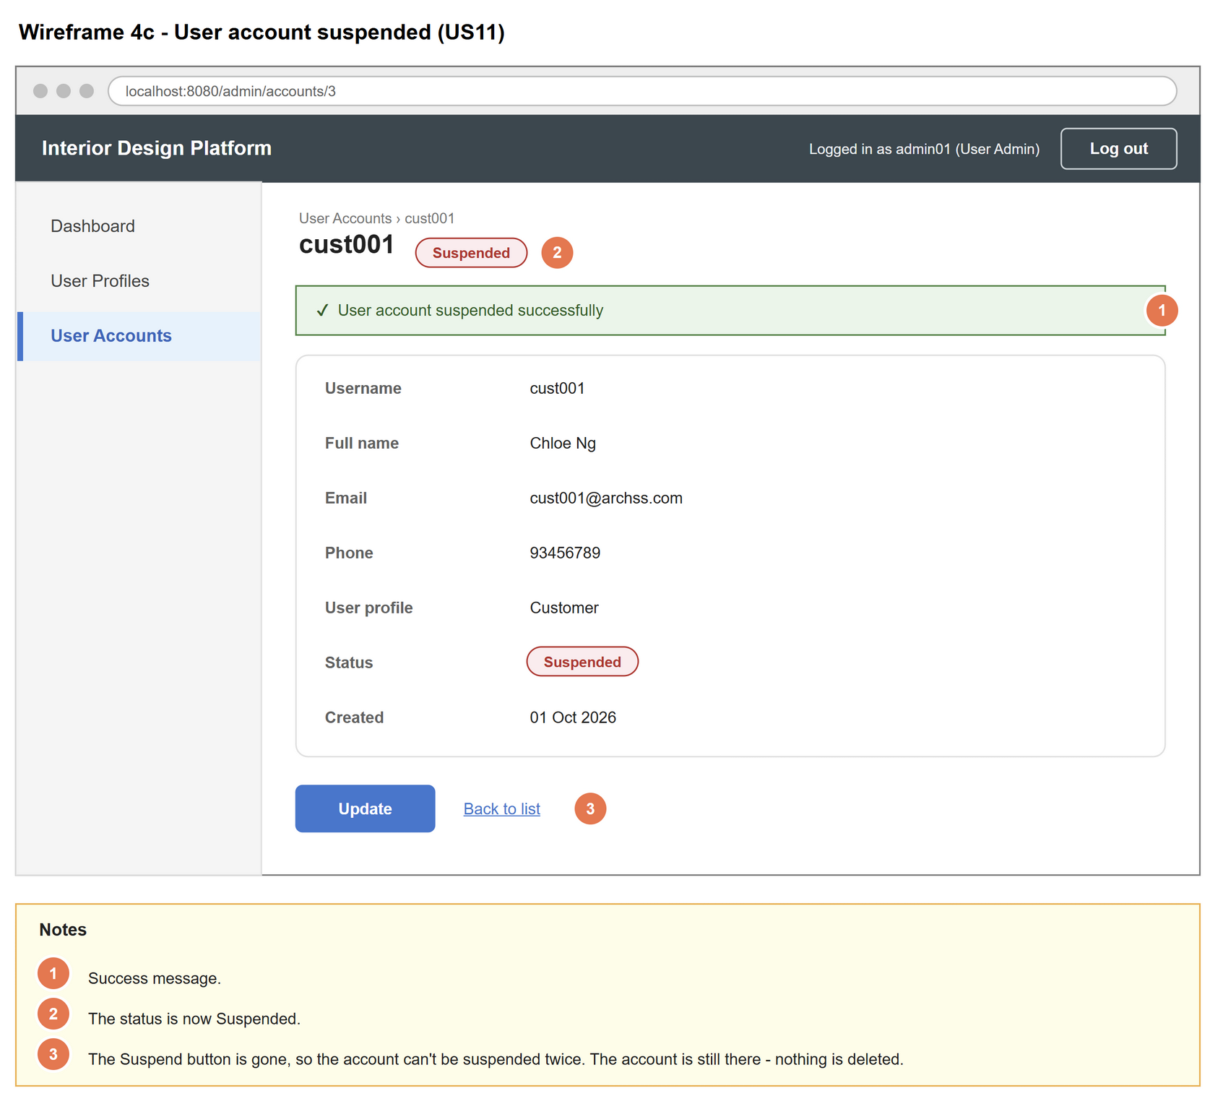
Figure 4: Wireframe 4c - Account suspended (US11)

4d - Blocked login
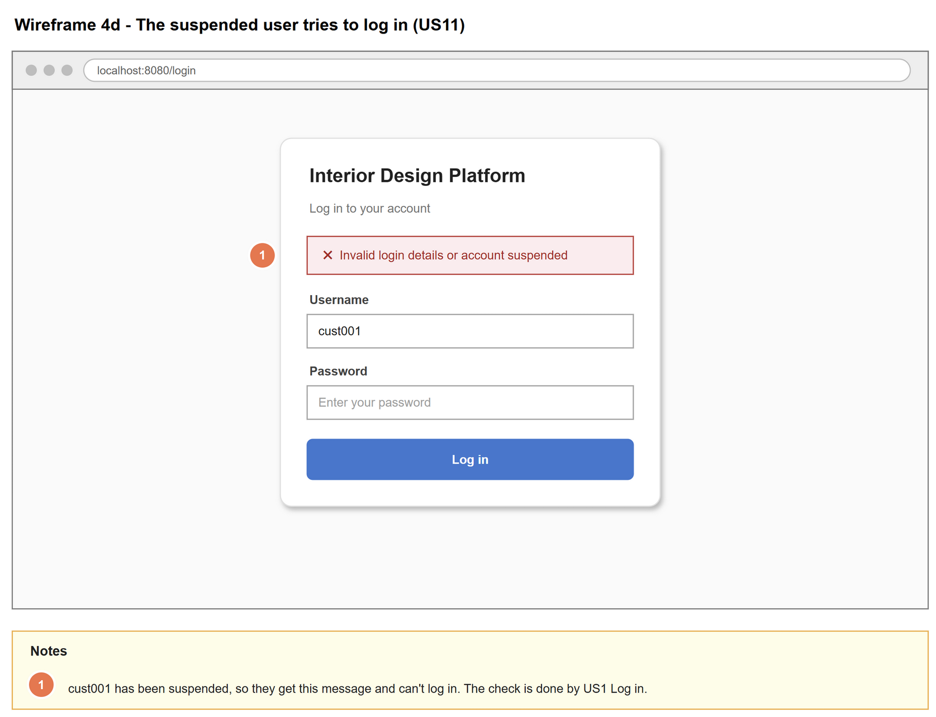
Figure 5: Wireframe 4d - Blocked login (US11)

5. B-C-E class diagram
The solid lines mean the boundary calls a controller (its own one, and US9's ViewUserAccountController for the confirmation box). The dashed lines mean a controller uses the entity class. Only the operations needed for this use case are shown.
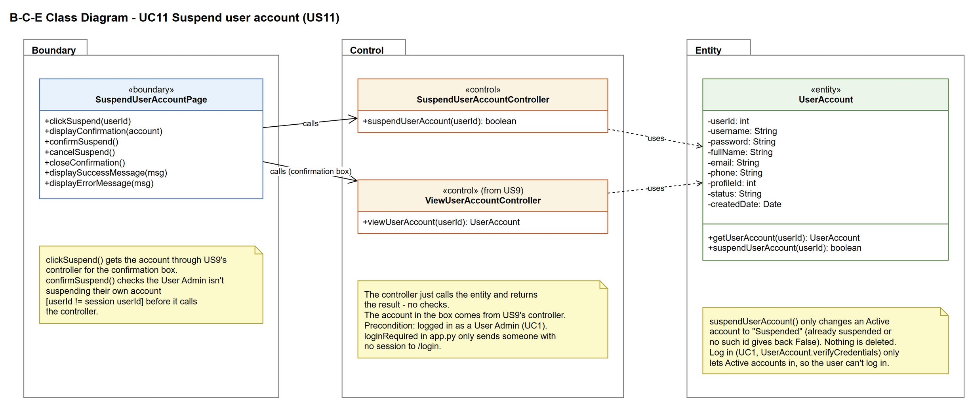
Figure 6: B-C-E class diagram for US11 Suspend user account
Layer | Class | What it does
Boundary | SuspendUserAccountPage | The Suspend button and the confirmation box on the account details page. Gets the account for the box through US9's ViewUserAccountController, checks it isn't the User Admin's own account (userId != session userId), passes the userId to the controller and shows the result.
Control | SuspendUserAccountController | Controller for UC11. suspendUserAccount(userId) just calls UserAccount.suspendUserAccount() and returns the result - no checks.
Control | ViewUserAccountController (from US9) | Borrowed from US9. viewUserAccount(userId) returns the account shown in the confirmation box (or None).
Entity | UserAccount | suspendUserAccount() changes the status to Suspended, but only for an Active account (already suspended or no such id gives back False). Log in (US1) only lets Active accounts in.

6. Sequence diagram
The sequence diagram follows UC11. The page first gets the account through US9's ViewUserAccountController (messages 2-5). If it exists, the confirmation box is shown (step 3); if not, an error is shown (alternative flow 2a). The next alt has the two choices: confirm (step 4) or cancel (alternative flow 4a). When confirmed, the page checks it isn't the User Admin's own account (step 5, alternative flow 5a). Then the controller just calls UserAccount.suspendUserAccount(), which only changes an Active account (step 6). The inner alt on suspended shows the success message (step 7) or the error message (alternative flow 6a).
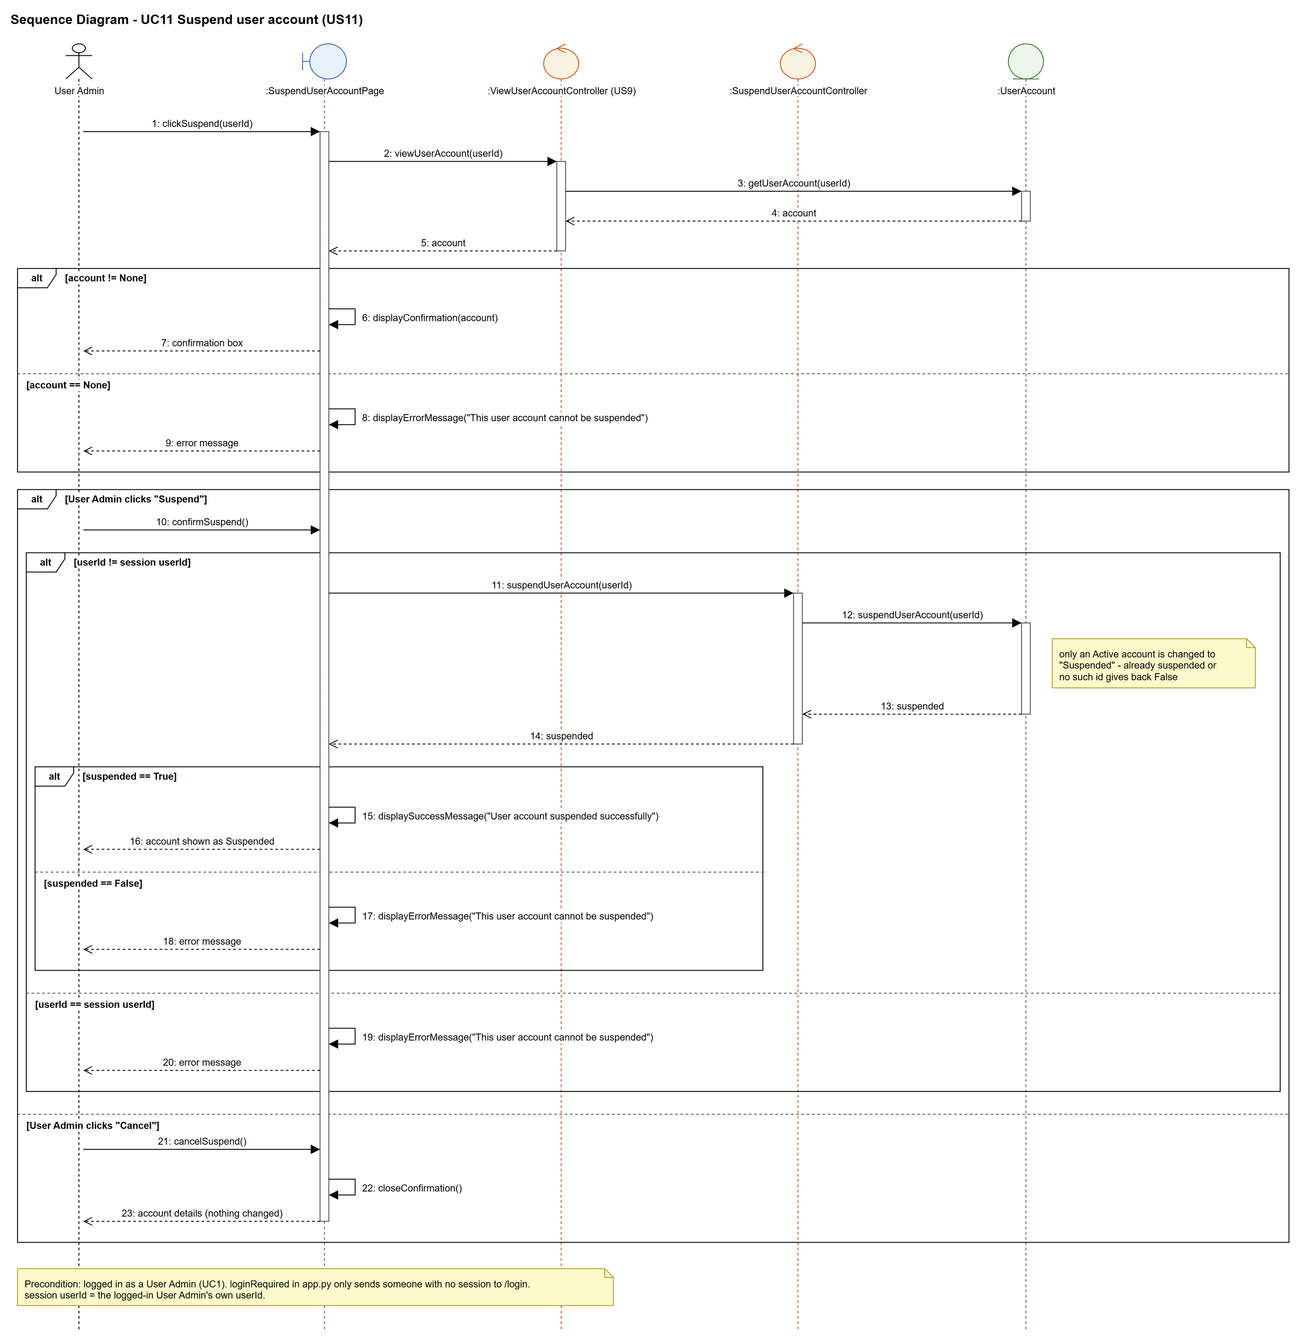
Figure 7: Sequence diagram for UC11 Suspend user account

7. Test cases
Test data used below (same as database/seedData.py): user profiles User Admin (id 1), Interior Designer (id 2), Customer (id 3) and Platform Manager (id 4), all Active. User accounts admin01 / Admin@123 (id 1, User Admin, Active), admin02 / Admin@123 (id 2, User Admin, Suspended), cust001 / Cust@123 (id 3, Customer, Active) and designer1 / Pass@123 (id 4, Interior Designer, Active).

7a. System test cases (black box)
Equivalence partitioning and boundary value analysis were used to pick the test data. Fill in "Actual result" and "Pass/Fail" after running each test.
Test ID | Scenario | Prerequisites | Test steps | Test data | Expected result | Actual result | Pass / Fail
TC11.1 | Suspend an active account | Logged in as admin01. cust001 is Active. | 1. View cust001  2. Click "Suspend"  3. Click "Suspend" in the confirmation box | cust001 | "User account suspended successfully". Status is Suspended. The Suspend button is no longer shown.
TC11.2 | The suspended user can't log in | TC11.1 done. | 1. Log out  2. Log in as cust001 | cust001 / Cust@123 | "Invalid login details or account suspended". Not logged in.
TC11.3 | Other users are not affected | TC11.1 done. | 1. Log in as admin01 | admin01 / Admin@123 | admin01 logs in normally.
TC11.4 | Nothing is deleted | TC11.1 done. | 1. Open the User Accounts list | cust001 | cust001 is still in the list (Suspended).
TC11.5 | Cancel the suspend | cust001 is Active. | 1. View cust001  2. Click "Suspend"  3. Click "Cancel" | cust001 | The box closes. Status is still Active.
TC11.6 | Confirmation names the account | cust001 is Active. | 1. View cust001  2. Click "Suspend" | cust001 | The box says cust001 (Chloe Ng) will not be able to log in.
TC11.7 | Already suspended account | Logged in as admin01. | 1. View admin02 | admin02 | No Suspend button is shown.
TC11.8 | Own account | Logged in as admin01. | 1. View admin01 | admin01 | No Suspend button is shown. admin01 stays Active.

7b. Unit test cases (for TDD)
These are written before the code (test-driven development) and run automatically in the CI pipeline. They cover normal inputs, abnormal inputs and boundary values.
Test ID | Class and method | Input / setup | Expected output | Type | Pass / Fail
UT11.1 | SuspendUserAccountController.suspendUserAccount() | 3 | Returns True. getUserAccount(3) has status "Suspended". | Normal
UT11.2 | SuspendUserAccountController.suspendUserAccount() | 2 (admin02 already Suspended) | Returns False | Abnormal
UT11.3 | SuspendUserAccountPage.confirmSuspend() | userId 1 while logged in as admin01 (POST /accounts/1/suspend) | "This user account cannot be suspended". The controller isn't called and admin01 is still Active. | Abnormal
UT11.4 | SuspendUserAccountController.suspendUserAccount() | 9999 | Returns False (no error thrown) | Abnormal
UT11.5 | UserAccount.isActive() | cust001 after UT11.1 | Returns False | Normal
UT11.6 | LoginController.login() | "cust001", "Cust@123" after UT11.1 | Returns None (can't log in) | Normal
UT11.7 | UserAccount.suspendUserAccount() | 3 | The number of rows in user_account is the same before and after | Normal
UT11.8 | SuspendUserAccountPage.clickSuspend() | 3 (GET /accounts/3/suspend) | The confirmation box names cust001 (Chloe Ng); the account comes from US9's ViewUserAccountController. Nothing is suspended yet. | Normal
UT11.13 | SuspendUserAccountPage.clickSuspend() | 9999 (GET /accounts/9999/suspend) | "This user account cannot be suspended" - no confirmation box. | Abnormal | Pass

